WASHINGTON COUNCIL OF LAWYERS Litigation Skills Series:
Trial Advocacy

Wednesday, May 6 –
Friday, May 8, 2025

Schedule

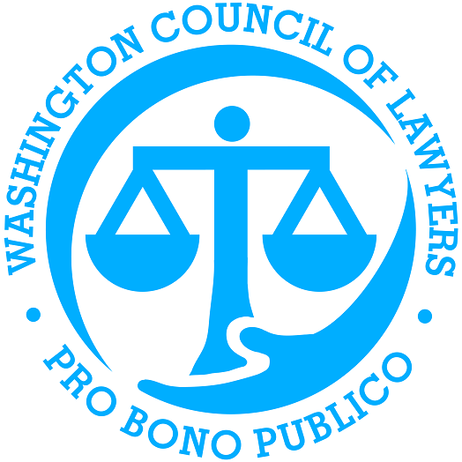

Washington Council of Lawyers
202.942.5063
info@wclawyers.org
www.wclawyers.org

Litigation Skills Series: Trial Advocacy

Wednesday, May 6
Virtual

11:00 – 11:05 Welcome/Overview of Course

11:05 – 12:00 Lecture: Opening Statements

12:00 – 12:20 Opening Statement Demonstration

12:20 – 12:30 PREP TIME TO REVISE OPENING STATEMENTS

12:30 – 1:30 Break Out Session 1: Opening Statements

Thursday, May 7
In-Person – Arnold & Porter
(601 Massachusetts Ave NW)
No virtual attendance.

9:00 – 9:15 Check-in & Coffee

9:15 – 10:15 Lecture: Direct Examination

10:15 – 10:45 Direct Examination Demonstration

10:45 – 11:00 PREP TIME TO REVISE DIRECT EXAMINATIONS

11:00 – 12:15 Break Out Session 2: Direct Examinations

12:15 – 1:15 Networking Lunch

1:15 – 2:15 Lecture: Cross Examinations

2:15 – 2:45 Cross Examinations Demonstration

2:45 – 3:00 PREP TIME TO REVISE CROSS EXAMINATIONS/ Snack

3:00 – 4:15 Break Out Session 3: Cross Examination

Friday, May 8
Virtual
9:00 – 10:00 Lecture: Closing Statements

10:00 – 10:20 Closing Statement Demonstration

10:20 – 10:30 PREP TIME TO REVISE CLOSING STATEMENTS

10:30 – 11:30 Break Out Session 1: Closing Statements

11:30 – 11:45 Wrap Up & Evaluation

